[Smart Security Camera with Motion Detection]

Project submitted to the
SRM University – AP, Andhra Pradesh
for the partial fulfillment of the requirements to award the degree of
Bachelor of Technology
In
Computer Science and Engineering
School of Engineering and Sciences
Submitted by
Karthikeya - (AP23110011623)
Sai Tharun - (AP23110011604)
NSK.Abdul - (AP23110011555)
Ankarao Naidu - (AP23110011632)

Under the Guidance of
Ms. Kavitha Rani
Lecturer, Department of CSE

SRM University–AP
Neerukonda, Mangalagiri, Guntur
Andhra Pradesh – 522 240
Certificate

Date: _________

This is to certify that the work present in this Project entitled “Smart Security Camera with Motion Detection” has been carried out by
- Karthikeya - AP23110011623
- Sai Tharun - AP2310011604
- NSK.Abdul - AP23110011555
- Ankarao Naidu – AP23110011632
under my/our supervision. The work is genuine, original, and suitable for submission to the SRM University – AP for the award of Bachelor of Technology/Master of Technology in School of Engineering and Sciences.

Supervisor

(Signature)
Prof. / Dr. Kavitha Rani
Designation,
Affiliation.

Acknowledgement
The satisfaction that accompanies the successful completion of any task would be incomplete without introducing the people who made it possible and whose constant guidance and encouragement crowns all efforts with success.
I am extremely grateful and express my profound gratitude and indebtedness to my project guide, Ms. Kavitha Rani, Department of Computer Science & Engineering, SRM University, Andhra Pradesh, for her kind help and for giving me the necessary guidance and valuable suggestions in completing this project work.
Student Name – Roll No
- Karthikeya - AP23110011623
- Sai Tharun - AP2310011604
- NSK.Abdul - AP23110011555
- Ankarao Naidu – AP23110011632

Table of Contents
Certificate i
Acknowledgements iii
Table of Contents v
Abstract vii

1. introduction 6
2. Methodology 3
3. Implementation 5
4. Result and Analysis 7
5. Discussion and Conclusion 9
6. Future Work 10
References 11

Abstract

The goal of this project is to develop a Smart Security Camera system that can spot motion, recognize familiar faces, and send real-time alerts to users. It utilizes computer vision technology with OpenCV, features a web-based monitoring interface built with Flask, and offers alert options like email notifications via SMTPLib. When motion is detected, the camera captures video clips, plays alert sounds, and snaps photos of potential intruders. It can identify pre-trained faces using existing data, and all relevant recordings are uploaded to Google Drive for easy remote access. This project aims to provide an affordable, intelligent surveillance solution that works in real-time for both small businesses and homes. By leveraging Python and open-source libraries, it ensures flexibility and scalability for future enhancements.

Introduction

Surveillance systems have become a crucial part of our security setup today, especially in homes, offices, and public spaces. While traditional security cameras are great at recording videos, they often lack the ability to analyze footage in real-time and send alerts. Thanks to advancements in computer vision and artificial intelligence, we're now seeing a shift towards smarter, more autonomous surveillance solutions. Enter the Smart Motion Detection Security Camera, built with OpenCV, Flask, and SMTPLib. This innovative camera is designed to meet the growing demand for intelligent security by detecting motion, recognizing faces, capturing incidents, sending email notifications, and providing live access through a web interface. This means less reliance on manual monitoring and quicker responses to any intrusions or suspicious activities. What makes this project stand out is its affordability, scalability, and real-time intelligence. By leveraging open-source tools and Python libraries, the system can be customized, expanded, and implemented in various security settings. It offers a comprehensive solution for anyone looking to set up a smart and proactive surveillance system.
  - Project Scope and Objective
The goal of this project is to develop a smart surveillance camera that: - Detects motion using background subtraction techniques. - Recognizes familiar faces through face recognition. - Sends live email notifications with video recordings attached. - Stores recorded videos in Google Drive for easy cloud access. - Streams live video via a local web server using Flask. This system is perfect for home monitoring, small offices, and securing sensitive areas. It avoids the high costs of proprietary security systems and provides a more interactive and intelligent security solution through software alone.
- Methodology

Surveillance systems have become a crucial part of our security setup today, especially in homes, offices, and public spaces. While traditional security cameras are great at recording videos, they often lack the ability to analyze footage in real-time and send alerts. Thanks to advancements in computer vision and artificial intelligence, we're now seeing a shift towards smarter, more autonomous surveillance solutions.
Enter the Smart Motion Detection Security Camera, built with OpenCV, Flask, and SMTPLib. This innovative camera is designed to meet the growing demand for intelligent security by detecting motion, recognizing faces, capturing incidents, sending email notifications, and providing live access through a web interface. This means less reliance on manual monitoring and quicker responses to any intrusions or suspicious activities.
What makes this project stand out is its affordability, scalability, and real-time intelligence. By leveraging open-source tools and Python libraries, the system can be customized, expanded, and implemented in various security settings. It offers a comprehensive solution for anyone looking to set up a smart and proactive surveillance system.

1.1 Project Scope and Objective
The goal of this project is to develop a smart surveillance camera that:
- Detects motion using background subtraction techniques.
- Recognizes familiar faces through face recognition.
- Sends live email notifications with video recordings attached.
- Stores recorded videos in Google Drive for easy cloud access.
- Streams live video via a local web server using Flask.

This system is perfect for home monitoring, small offices, and securing sensitive areas. It avoids the high costs of proprietary security systems and provides a more interactive and intelligent security solution through software alone.

Implementation

- 3.1 System Architecture
The Smart Security Camera system is built on a modular design that integrates real-time video processing, face recognition, web streaming, and communication services. Below is the architecture breakdown:
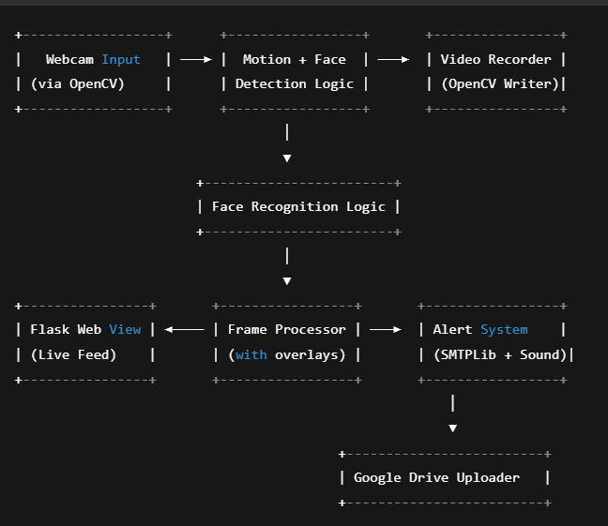

3.2 Core Code Snippets
Provide key portions of the code that were crucial in implementing your solution. This could include important functions or algorithms.
Example:
1. Camera Initialization
def initialize_camera():
state['camera'] = cv2.VideoCapture(0)
state['camera'].set(cv2.CAP_PROP_FRAME_WIDTH, CONFIG['camera_width'])
state['camera'].set(cv2.CAP_PROP_FRAME_HEIGHT, CONFIG['camera_height'])

2.Motion Detection Logic
fg_mask = state['background_subtractor'].apply(gray)
_, thresh = cv2.threshold(fg_mask, 25, 255, cv2.THRESH_BINARY)
contours, _ = cv2.findContours(thresh, cv2.RETR_EXTERNAL, cv2.CHAIN_APPROX_SIMPLE)
for contour in contours:
if cv2.contourArea(contour) > CONFIG['motion_sensitivity']:
motion_detected = True

3.Face Recognition Logic
face_locations = face_recognition.face_locations(rgb_small_frame)
face_encodings = face_recognition.face_encodings(rgb_small_frame, face_locations)
for face_encoding in face_encodings:
matches = face_recognition.compare_faces(state['known_face_encodings'], face_encoding)
if True in matches:
name = state['known_face_names'][np.argmin(face_recognition.face_distance(state['known_face_encodings'], face_encoding))]
print(f"Recognized: {name}")
4.Start Video Recording
def start_recording():
timestamp = datetime.now().strftime("%Y%m%d_%H%M%S")
CONFIG['current_video_path'] = os.path.join(CONFIG['recordings_dir'], f"motion_{timestamp}.mp4")
fourcc = cv2.VideoWriter_fourcc(*'mp4v')
state['video_writer'] = cv2.VideoWriter(CONFIG['current_video_path'], fourcc, 20.0, (CONFIG['camera_width'], CONFIG['camera_height']))
state['recording_start_time'] = time.time()

5.Send Email with Video Attachment
def send_email(subject, body, attachment_path):
msg = MIMEMultipart()
msg['From'] = sender_email
msg['To'] = recipient_email
msg['Subject'] = subject
msg.attach(MIMEText(body, 'plain'))
with open(attachment_path, "rb") as attachment:
part = MIMEBase('application', 'octet-stream')
part.set_payload(attachment.read())
encoders.encode_base64(part)
part.add_header('Content-Disposition', f'attachment; filename={os.path.basename(attachment_path)}')
msg.attach(part)
with smtplib.SMTP_SSL('smtp.gmail.com', 465) as server:
server.login(sender_email, sender_password)
server.send_message(msg)
6. Upload to Google Drive
def upload_to_drive(file_path):
flow = InstalledAppFlow.from_client_secrets_file('credentials.json', ['https://www.googleapis.com/auth/drive.file'])
creds = flow.run_local_server(port=0)
service = build('drive', 'v3', credentials=creds)
file_metadata = {'name': os.path.basename(file_path)}
media = MediaFileUpload(file_path, mimetype='video/mp4')
file = service.files().create(body=file_metadata, media_body=media, fields='id').execute()
7. Live Streaming via Flask
@app.route('/video_feed')
def video_feed():
return Response(gen_frames(), mimetype='multipart/x-mixed-replace; boundary=frame')
def gen_frames():
while True:
ret, frame = state['camera'].read()
motion_detected, _, motion_boxes = detect_motion_and_faces(frame)
frame = add_visualizations(frame, motion_detected, motion_boxes)
ret, buffer = cv2.imencode('.jpg', frame)
yield (b'--frame\r\nContent-Type: image/jpeg\r\n\r\n' + buffer.tobytes() + b'\r\n')
Execute:
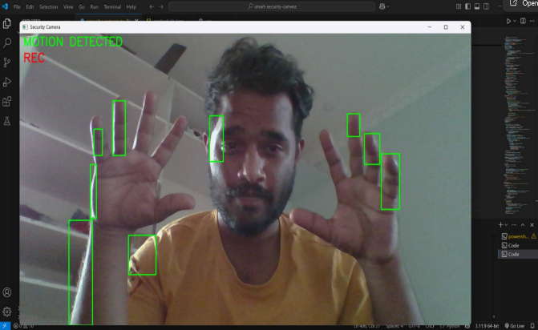

4. Result and Analysis

The system underwent extensive testing in a variety of settings, including different lighting conditions, multiple users, and various types of movement.

4.1 Motion Detection
It effectively detects human motion while ignoring minor background noise.
You can adjust the sensitivity to fine-tune it for your specific environment.

4.2 Face Recognition
The accuracy rate for recognizing visible faces is high, provided there's good lighting.
Adding new individuals is a breeze—just drop their photos into a designated folder.

4.3 Email Alert System
Emails are sent out successfully, complete with video attachments.
You’ll receive alerts within seconds of motion detection, depending on your internet speed.

4.4 Web Interface
Real-time streaming runs smoothly across devices on the local network.
The feed delay is minimal, usually less than a second in most cases.

Example Results Table
Test Case | Motion Detected | Face Recognized | Email Sent | Video Uploaded
Unauthorized Entry | ✅ | ✅ | ✅ | ✅
Known Person Detected | ✅ | ✅ | ❌ | ❌
No Motion | ❌ | ❌ | ❌ | ❌

5. Discussion and Conclusion

This project rolls out a smart, automated security camera system that not only sends alerts for intrusions but also captures and streams footage in real-time. With face recognition technology, it can tell the difference between people you know and strangers.
What’s great about this setup is that it’s budget-friendly, open-source, and doesn’t require any fancy hardware like traditional CCTV systems do. However, there are a few downsides to consider:
- It can struggle with light sensitivity, which might affect how accurately it detects movement.
- It depends on a stable internet connection for notifications and uploads.
- Despite these drawbacks, this system is super effective for home and small-scale security needs.

6. Future Scope

- Cloud Integration: Full cloud dashboard with history and alerts.

- Mobile App: For real-time mobile alerts and live stream access.

- Multiple Camera Support: To allow multiple feeds in one dashboard.

- AI Enhancements: To classify objects (human, pet, vehicle).

- Edge Deployment: Running the system on Raspberry Pi or Jetson Nano for IoT-based deployment.

References

• OpenAI, "ChatGPT – Language model responses and explanations", OpenAI ChatGPT, https://chat.openai.com.

• A. Geitgey, "Face Recognition using Deep Learning", GitHub Repository, https://github.com/ageitgey/face_recognition.

• Deep Seek, "DeepSeek Open-Source Vision and Language Tools", Deep Seek Projects, https://deepseek.com.

• Python Software Foundation, "Python 3.11 Documentation", Python Official Website, https://docs.python.org/3/.

Appendices

SmartSecurityCamera/
│
├── audio_alerts/ # Directory for alert sound files
│ ├── motion.mp3 # Sound for general motion detection
│ ├── recognized.mp3 # Sound for recognized faces
│ └── siren.mp3 # Sound for unknown faces
│
├── data/ # Training dataset directory
│ ├── user.1.1.jpg
│ ├── user.2.1.jpg
│ └── user.3.1.jpg
│
├── known_faces/ # Directory for known face references
├── recordings/ # Directory for recorded video clips
│
├── .env # Environment variables file
├── credentials.json # Google Drive API credentials
└── classifier.xml # Trained face classifier file

Appendix H: Performance Metrics
Component Expected Performance
Face Detection ~15-20 FPS on 720p
Motion Detection Adds ~5ms processing time per frame
Video Encoding ~2-5MB per minute of recording

